Digital Design

Create designs to show emotion

Create several drawings, design or photographs that show emotions like sadness, joy, love, happiness etc.

You must create at least 10 images, drawings or designs

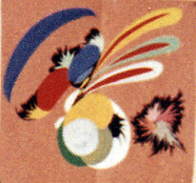 Joy

Some sample s from previous student work

 Satisfaction

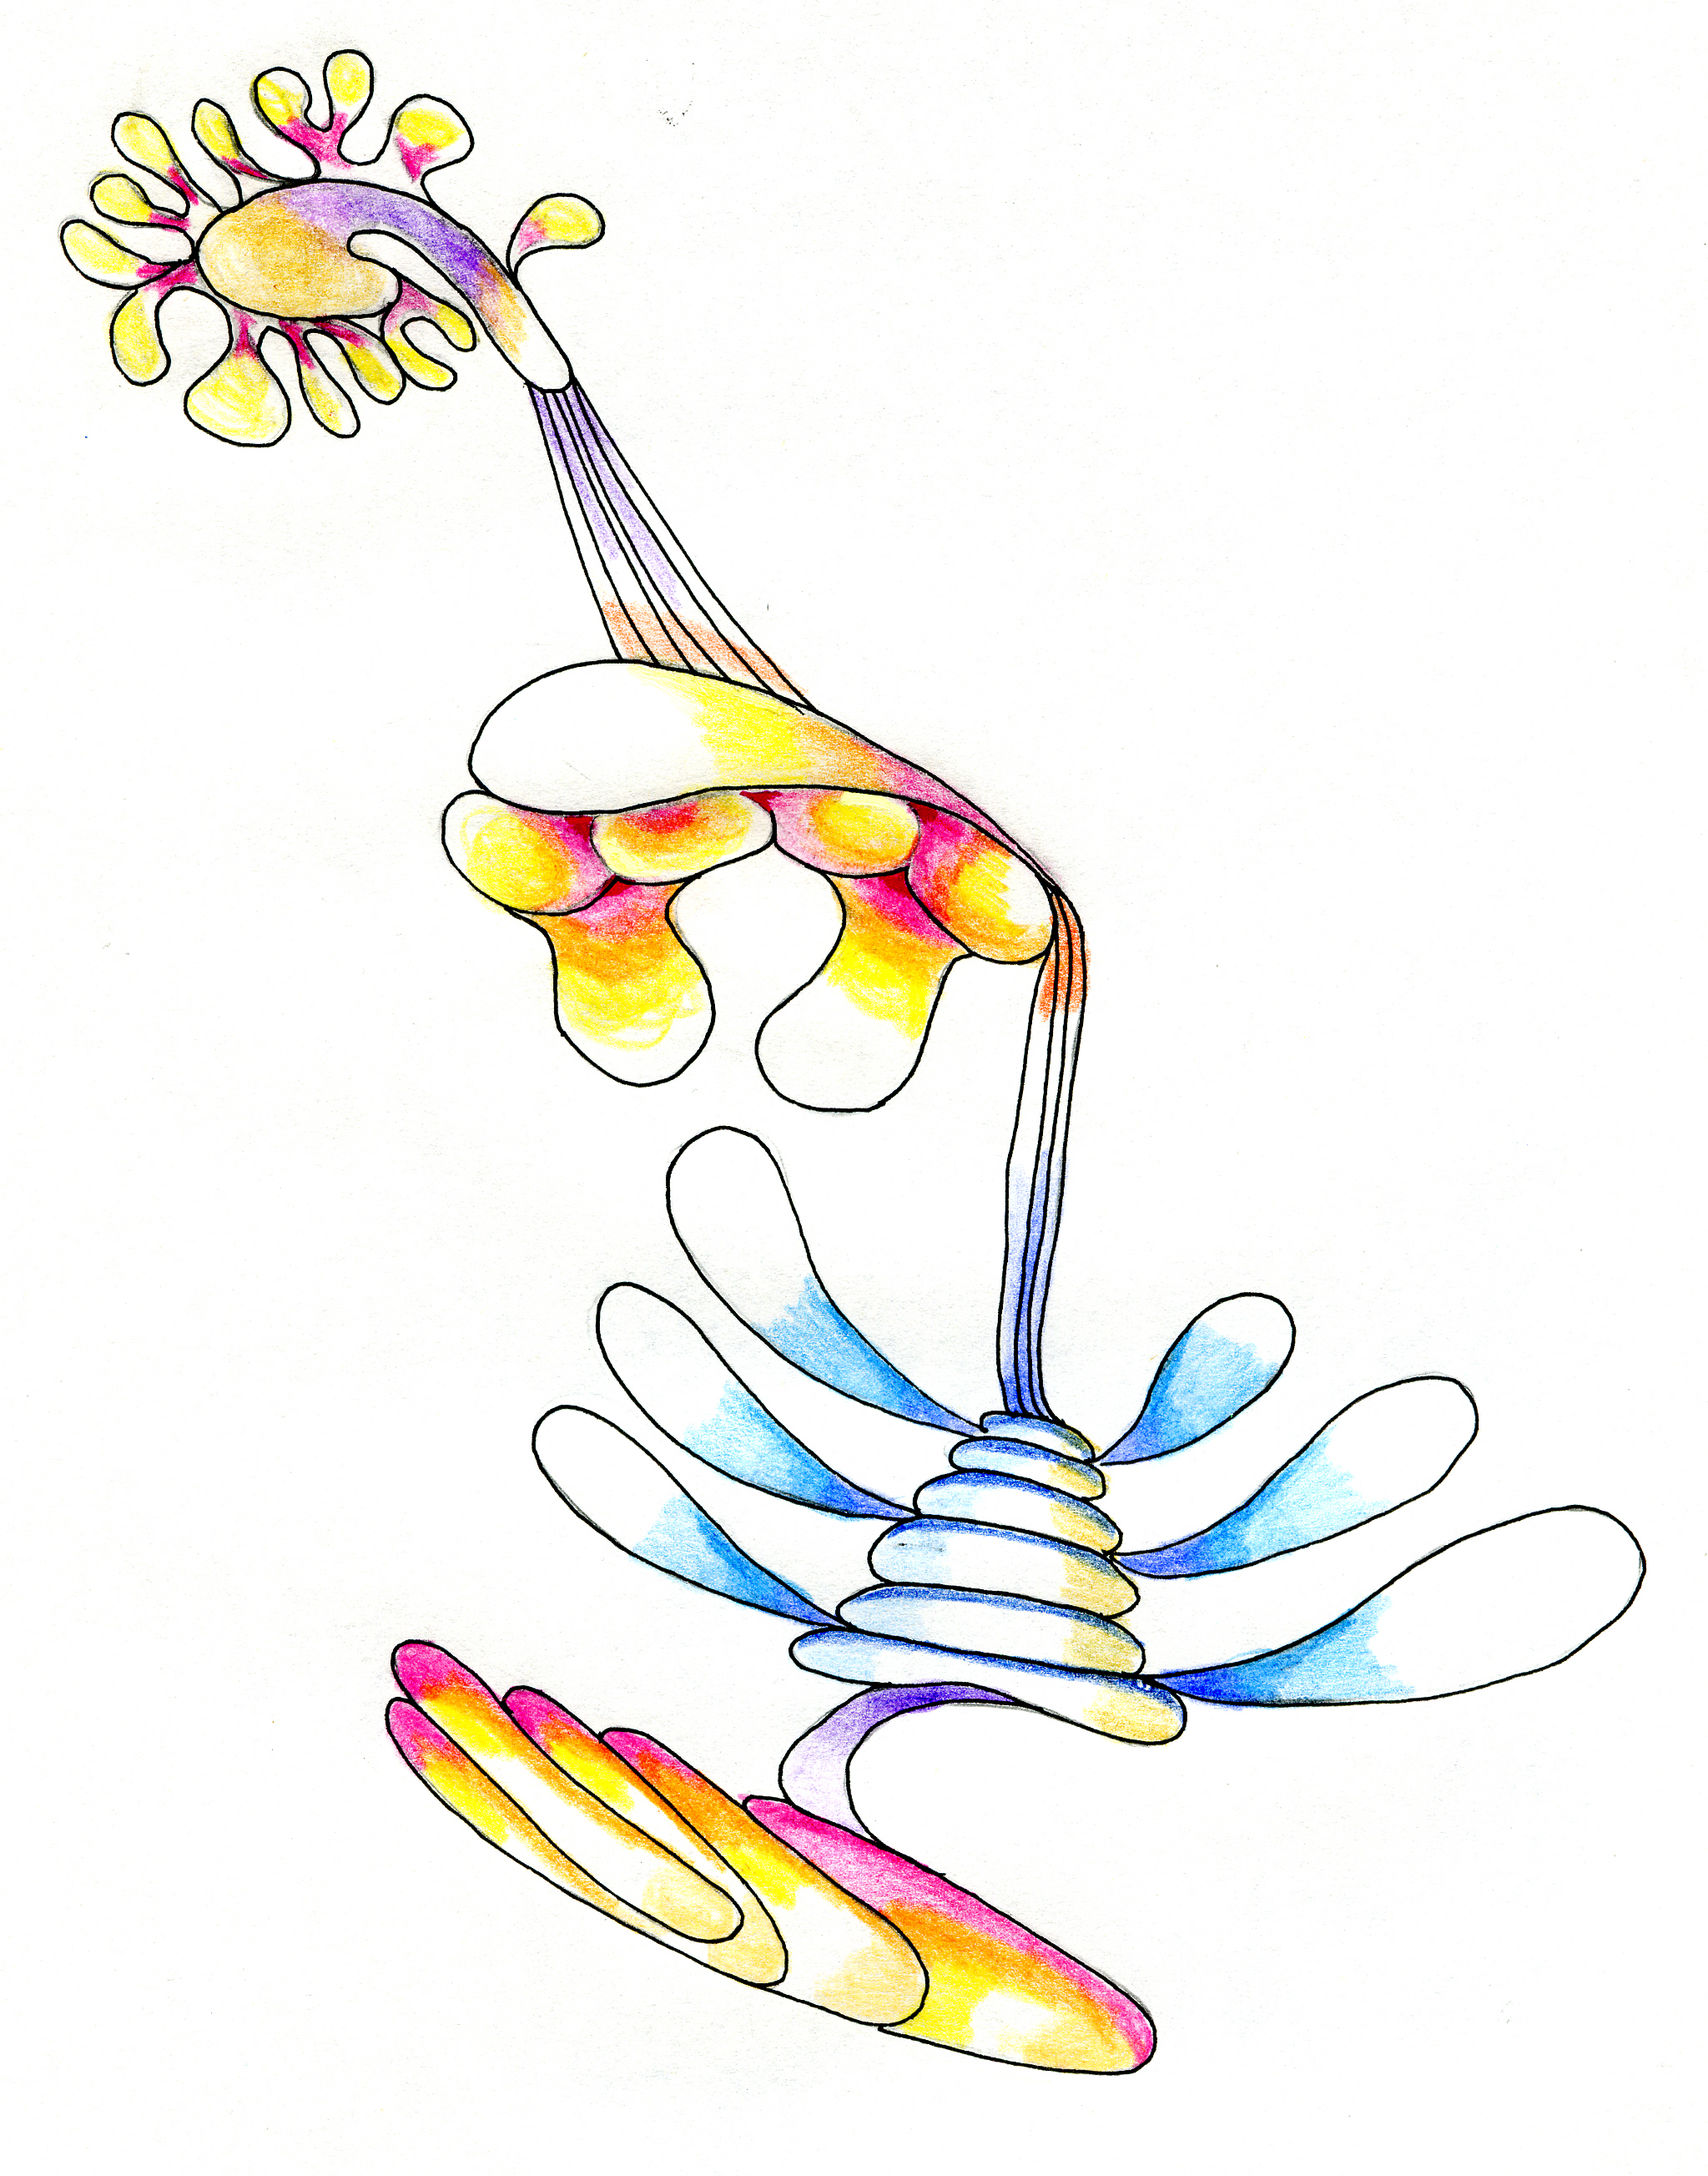Happiness

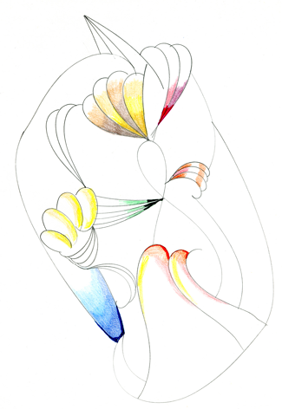
Love
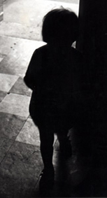

Sadness



Power


Need help just ask

